Operating responsibly and sustainably is important to our company.
Although at Armour Security Group (UK) Ltd we run our business activities in line with the expectations of our diverse stakeholders, we also see corporate responsibility as a discipline that helps us to manage risks and maximize the opportunities presented to us in a changing global environment. We take our corporate responsibility seriously within our company as an employer, provider, investor, and consumer. We are committed to understanding, monitoring, and managing our social, environmental, and economic impact to enable us to contribute to society’s wider goal of sustainable development. We aim to demonstrate these responsibilities through our actions and within our corporate policies.
We focus our CSR activities on the following key impact areas:
Workplace our ability to deliver world-class products is dependent on a talented, engaged workforce in all the countries in which we operate. To this end, we are focused on making Armour Security Group (UK) Ltd a place where people feel supported, can develop their skills, and have a clear understanding of our business objectives. We are committed to ensuring that our entire business is conducted according to rigorous professional, ethical, and legal standards.
Additionally, we:
Operate an equal opportunities policy for all present and potential future employees
Offer our employees clear and fair terms of employment and provide resources to enable their continual development
Maintain a clear and fair employee remuneration policy and maintain forums for employee consultation and business involvement.
Health & Safety
We shall provide, and strive to maintain, a clean, healthy, and safe working environment providing a workplace where our employees feel safe is not only a legal obligation, but a fundamental factor in building their engagement with the company. Through management intervention, awareness campaigns, and a culture that encourages employees to raise concerns about workplace safety, we aim to reduce the frequency of accidents.
Our Health & Safety department challenges and develops cooperation between all managers and employees to ensure health and safety management is embedded into management and business processes. This is supported by our Health & Safety Policy.
Marketplace We are in business to deliver value to our customers. All that we do is geared to providing world-class services and products and the best possible customer experience. We have a passion for excellence, and we take pride in our ability to solve our customers’ problems, focusing on delivering innovative solutions promptly. We aim for true customer satisfaction by understanding our clients’ needs and building partnerships.
Environment We recognize the importance of understanding the impact of our activities on the environment and we are developing an environmental program to demonstrate and benchmark our commitment. The environmental program addresses pollution control of chemicals, energy and water efficiency, and waste reduction, all of which are subject to continuous review.
The Program also seeks to reduce the impact of our global carbon footprint and we will achieve this by monitoring carbon emissions and reporting them on an annual basis.
Community
We are committed to making a sustainable positive impact on the communities in which we operate. We aim to make a distinctive contribution to inequality and social development through the establishment of effective partnerships and programs that make the best use of the energies and skills of our employees. We support our employees in fundraising for charities and voluntary work, recognizing both the benefit to the community and to the employees themselves. We also regularly choose relevant charities and sponsorships from within the communities we are involved with.

The Managing Director shall review this policy annually or following significant changes.
Approved by
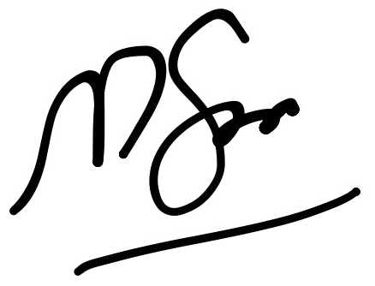
Muazzam Saleem

Managing Director
ARMOUR SECURITY GROUP (UK) LTD
Date: 01/01/2026

