HEALTH AND SAFETY POLICY STATEMENT
At Armour Security Group (UK) Ltd, we provide security guarding, key holding and intruder alarm response services to residential and business premises. The top management at Armour Security Group (UK) Ltd is fully committed to controlling health and safety risks arising from our work activities in compliance with the Health and Safety at Work Act 1974. We actively consult with our employees on all matters related to their health and safety in the workplace.
Armour Security Group (UK) Ltd ensures the safe handling and use of substances and provides employees with adequate information, instruction, and supervision. We are committed to ensuring that all employees are competent in performing their tasks and are provided with appropriate training.
As a responsible employer, Armour Security Group (UK) Ltd understands its duty to report serious workplace accidents, occupational diseases, and specified dangerous occurrences (near misses) under the RIDDOR - Reporting of Injuries, Diseases and Dangerous Occurrences Regulations 2013. We are dedicated to preventing accidents and cases of work-related ill health, and to maintaining safe and healthy working conditions.
To achieve this, we provide, as far as is reasonably practicable:
- A safe system of work.
- Safe plant and equipment.
- Safe methods for handling and transporting articles, substances, and people.
- Adequate training, instruction, information, and supervision.
- A safe workplace with safe access and egress.
- A safe and healthy environment.
- Adequate welfare facilities.
Management at Armour Security Group (UK) Ltd is committed to ensuring, as far as is reasonably practicable, that our security operations do not affect the health and safety of non-employees, such as visitors and contractors.
Additionally, we recognize our duty to ensure that any articles, substances, or equipment we produce, erect, or install are safe for use and that all necessary health and safety information is made available.
Approved by
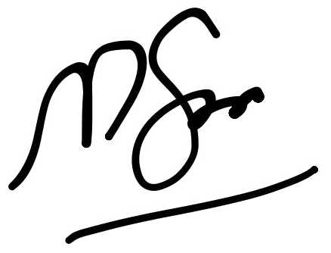
Muazzam Saleem
Managing Director
ARMOUR SECURITY GROUP (UK) LTD
Date: 01/01/2026

