Company Quality Policy

Armour Security Group (UK) Ltd provides security services across a variety of sectors, including construction, healthcare, retail, residential, and leisure. We are committed to delivering the highest levels of customer service while respecting the customer’s right to be actively involved in improving their contract with the Company. We continuously strive to expand our market share through a diligent focus on quality control and human resource development programs.

We provide well-trained, disciplined, and professional workforce, motivated to deliver exceptional service to our customers. Our workforce is rigorously screened in accordance with BS 7858 standards, ensuring the highest levels of security and professionalism.

Our commitment to quality management spans all aspects of the business. This Quality Manual presents the organization’s Quality Management System to all personnel, offering essential guidance for the effective implementation of quality control measures. It serves as a fundamental reference for policies, processes, and procedures, including any necessary work instructions, outlining the activities and responsibilities each employee must undertake as part of their role.
The Managing Director is responsible for determining the criteria and methods to ensure the effective operation and control of processes, as well as for ensuring the availability of resources and information necessary to support these processes. Armour Security Group (UK) Ltd’s Quality Policy provides the framework for establishing, maintaining, and improving the organization’s quality objectives.
The organization will monitor, measure, and analyse its processes, ensuring that actions are taken to achieve planned results and continually improve their effectiveness. Our goal is to ensure that any changes required to our documented management system, to meet the requirements of BS EN ISO 9001:2015, are performed in a managed and methodical way. This guarantees that the system is fully understood and effectively implemented throughout the company.

Armour Security Group (UK) Ltd will make this Policy available to all stakeholders, shareholders, employees, and the public upon request.

Approved by
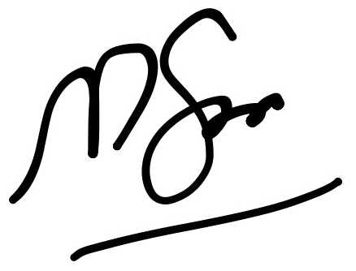
Muazzam Saleem
Managing Director
ARMOUR SECURITY GROUP (UK) LTD
Date: 01/01/2026

